Introduction to SQL tutorial set up

The following instructions show the steps on how to setup the DB Browser Access and open the ‘sample_ecomm’ database for the tutorial:

- Open a browser (Chrome Or Firefox Or Microsoft Edge, etc), and go to
https://rdweb.wvd.microsoft.com/arm/webclient/index.html
- You will see the following in the browser:
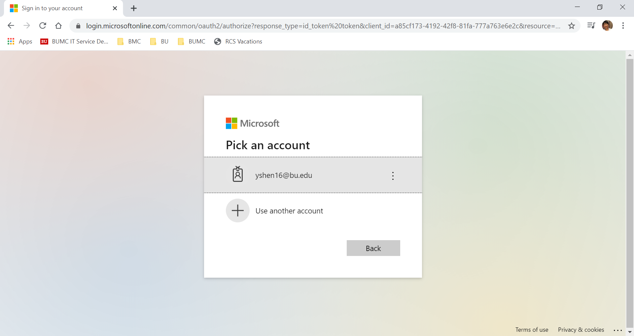

- You need to pick your own bu login or use tutorial account to log in.

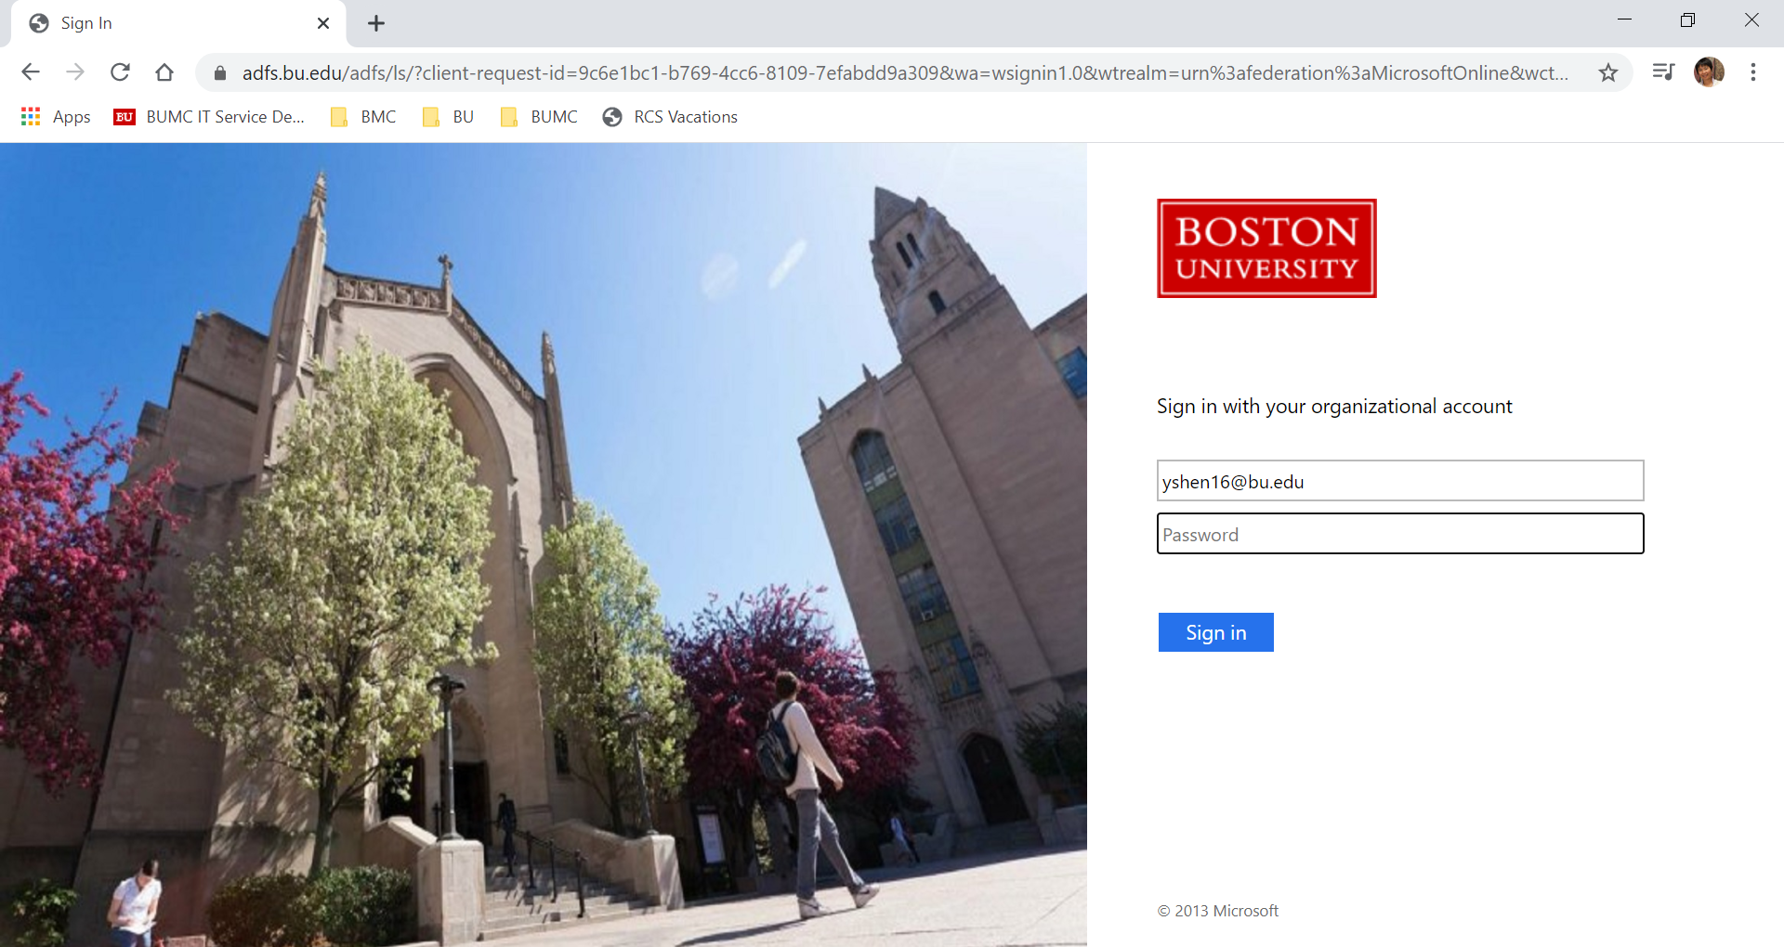

- After log in, you will see the following in the browser:

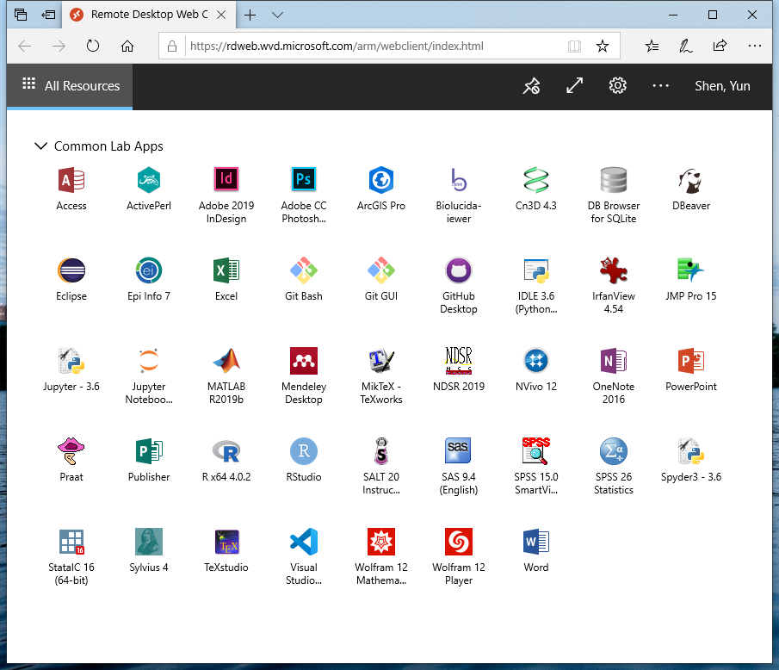

- Click on ‘DB Browser for SQLite’ icon and start the application:

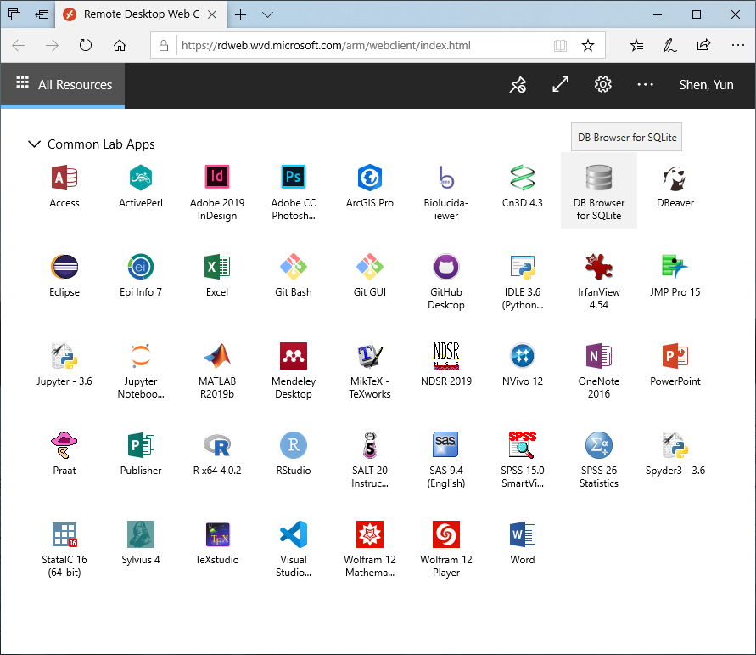

- It will prompt you to enter the credential again and this time is for access to DB browser app, type your BU login or tutorial account login info:

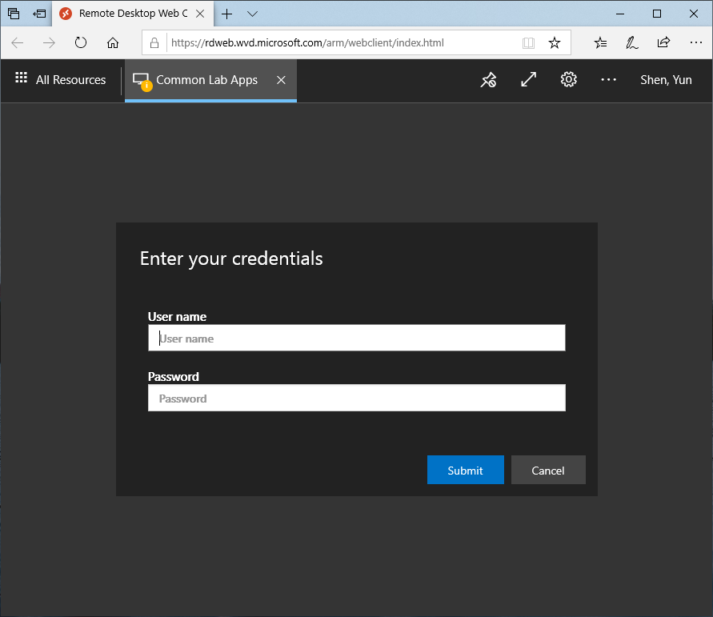

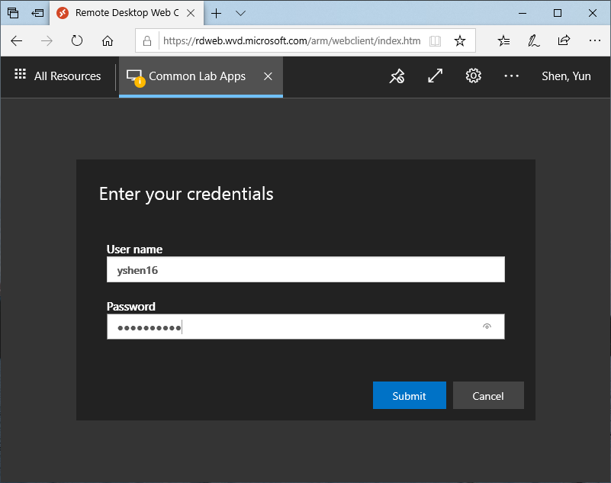

- It will bring you to the DB Browser user interface:
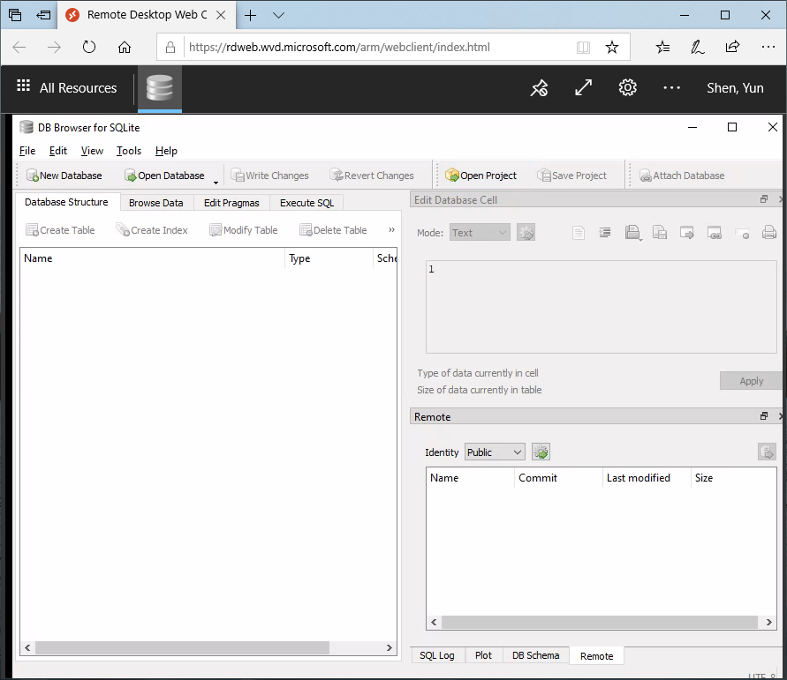
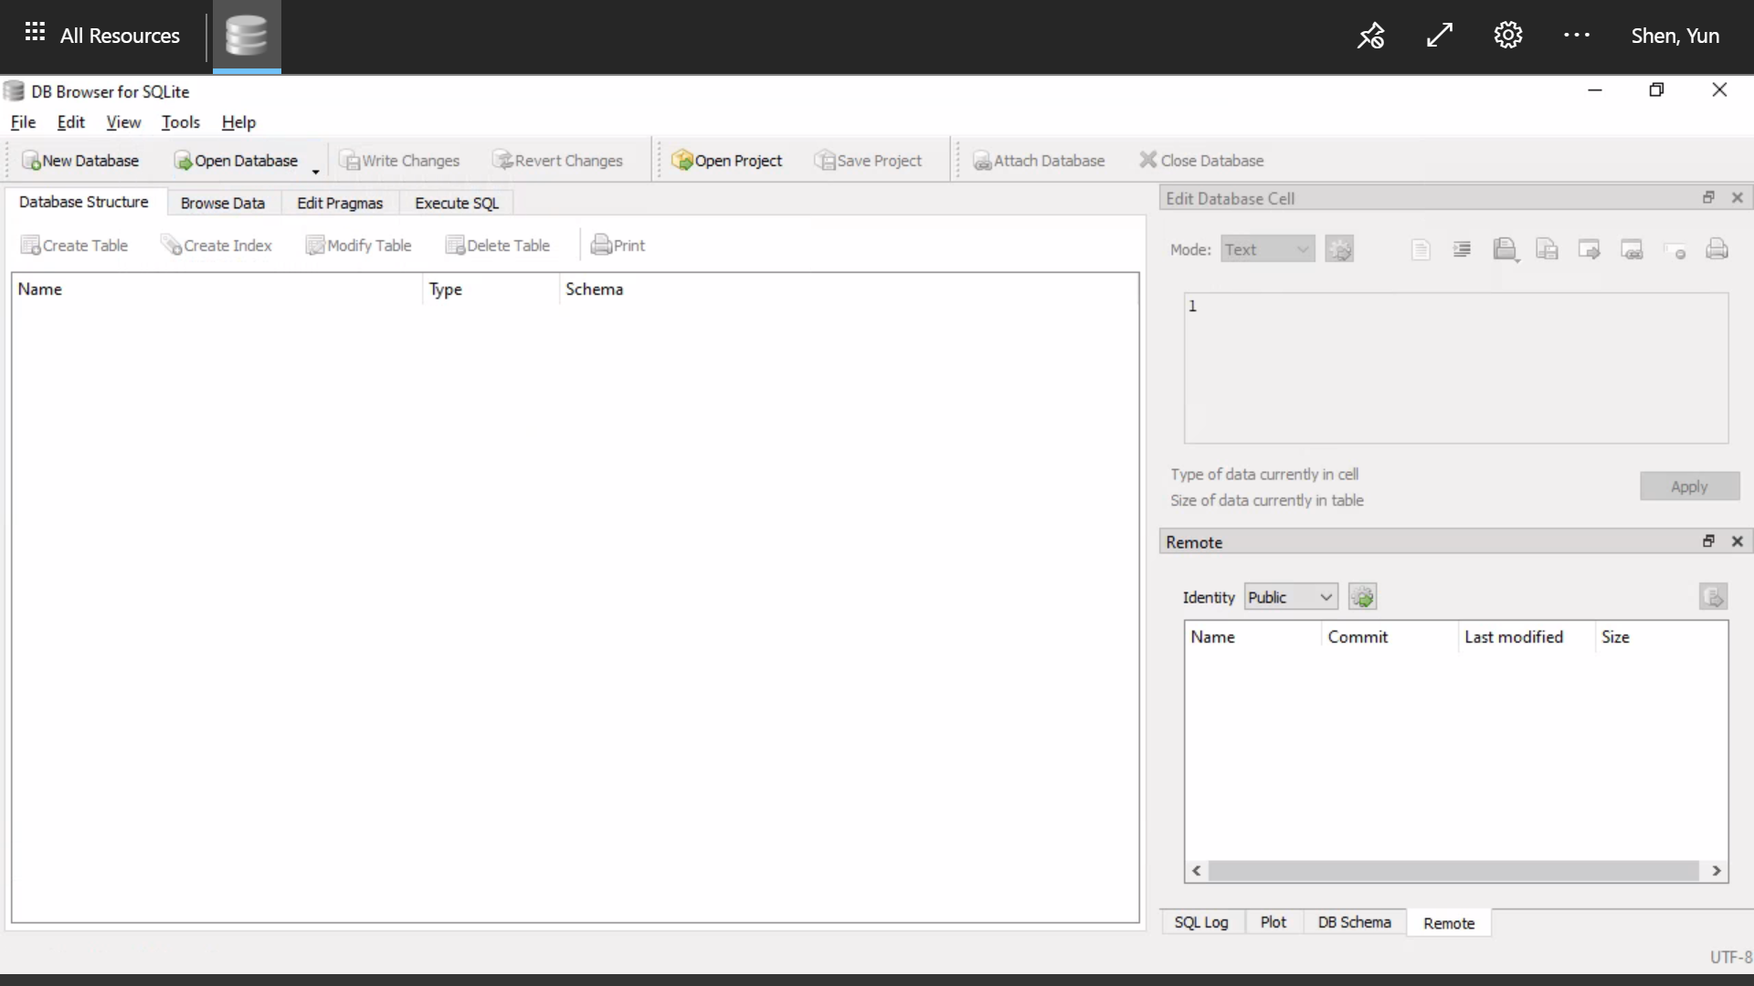

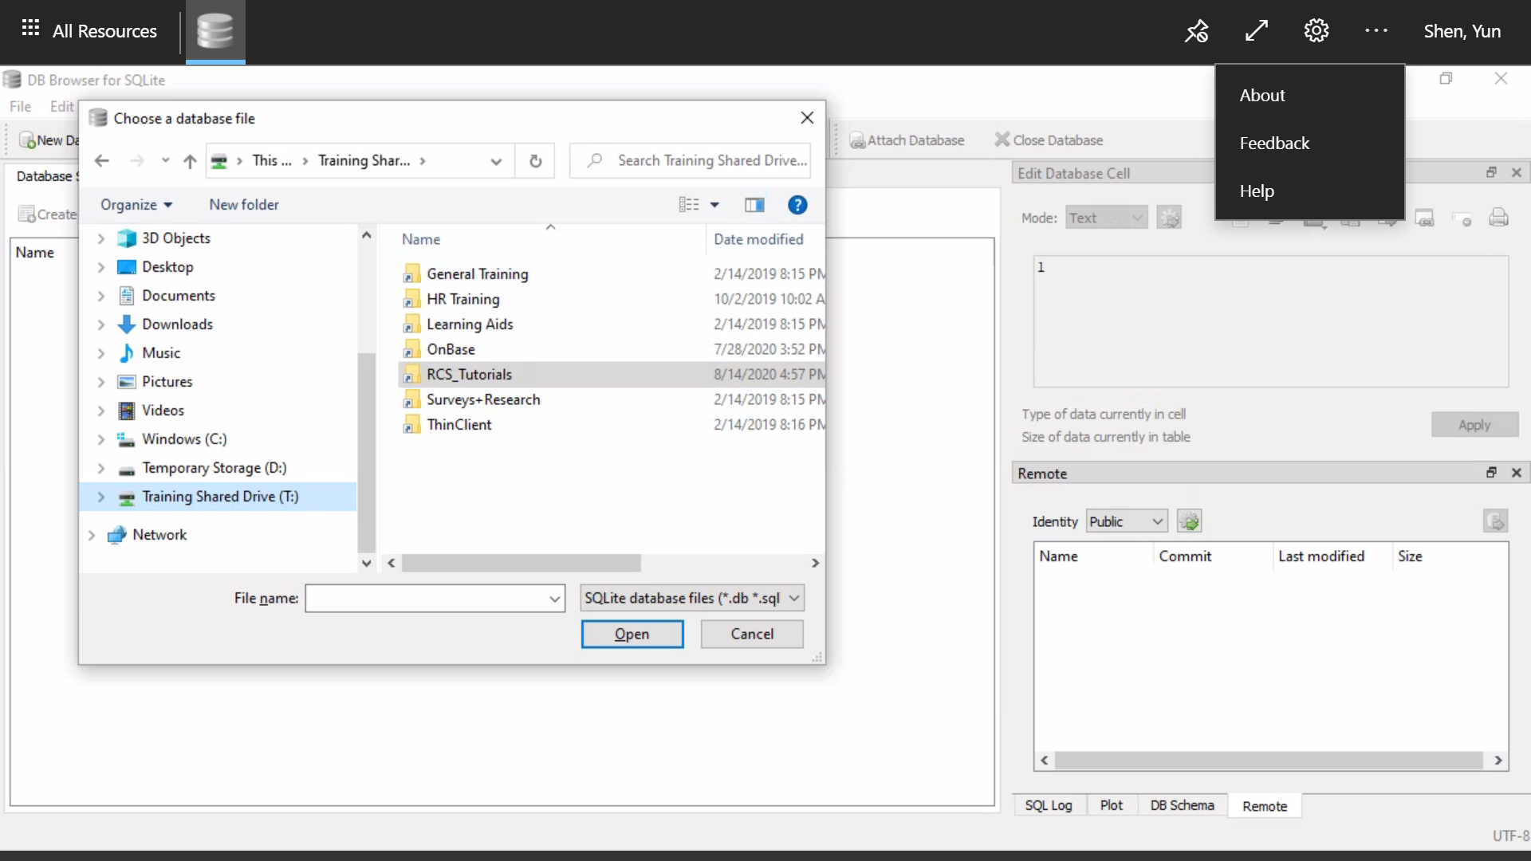
- Open database file at ‘This PC -> Training Share Drive (T:) -> RCS_Tutorials -> Tutorial Files -> Intro2SQL->tutfiles->db->sample_ecomm.db’ :

- Find the file sample_ecomm.db (depending on your setting, ‘.db’ may not show), at this point, I would like you to do an extra step – to make a copy of this file to ‘Documents’. You can do so by right click the mouse and then select ‘copy’ from the pop up menu as below:
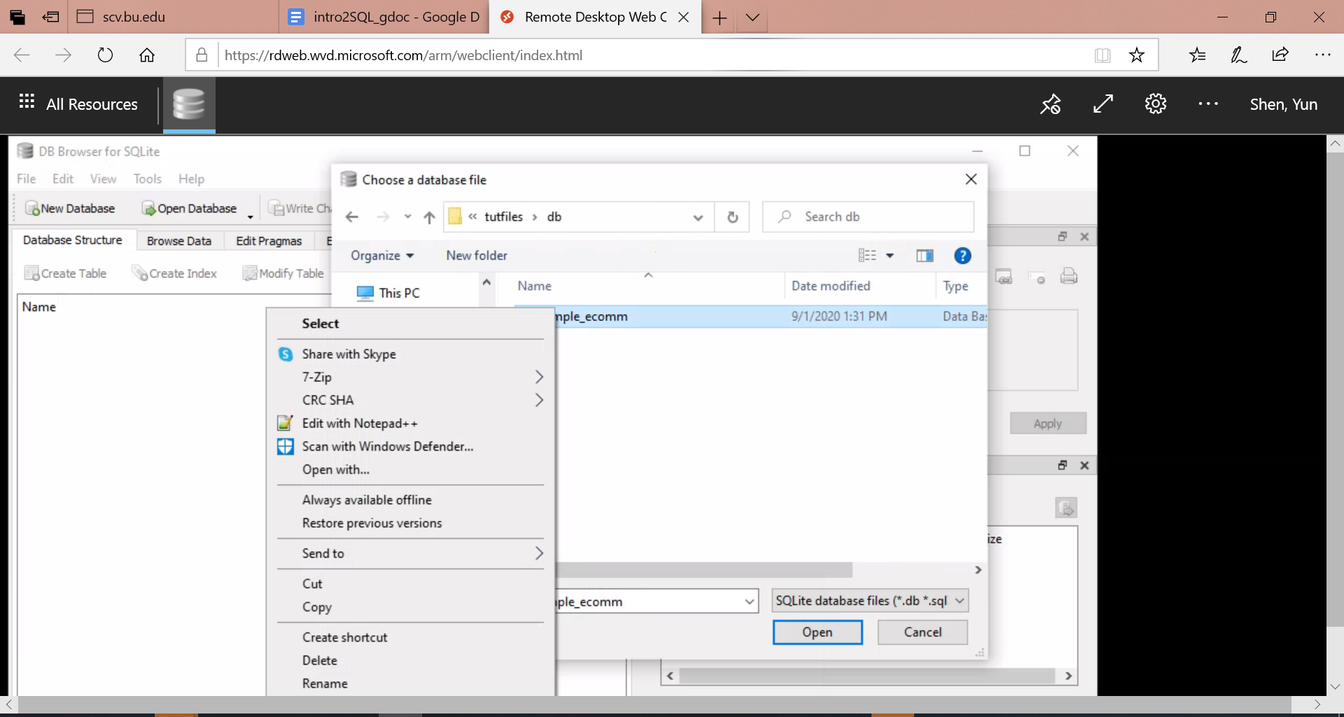

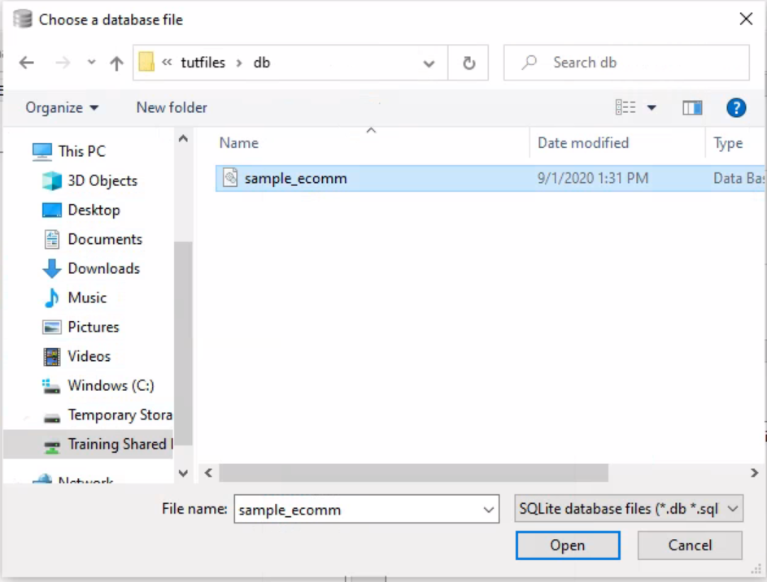
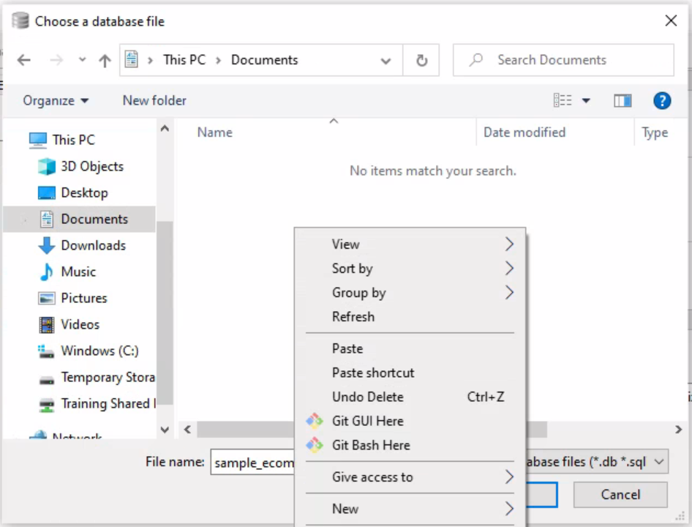
- Select this sample_ecomm.db file, click ‘open’:
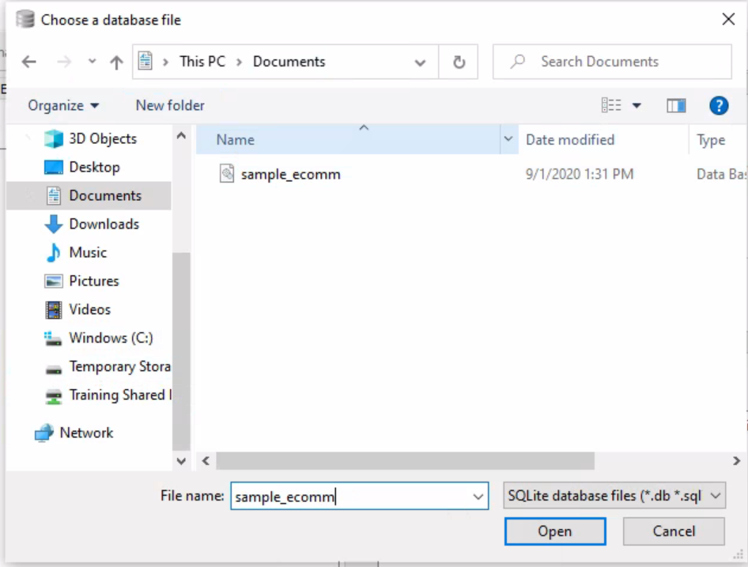

- This will open the sample_ecomm.db in DB Browser:

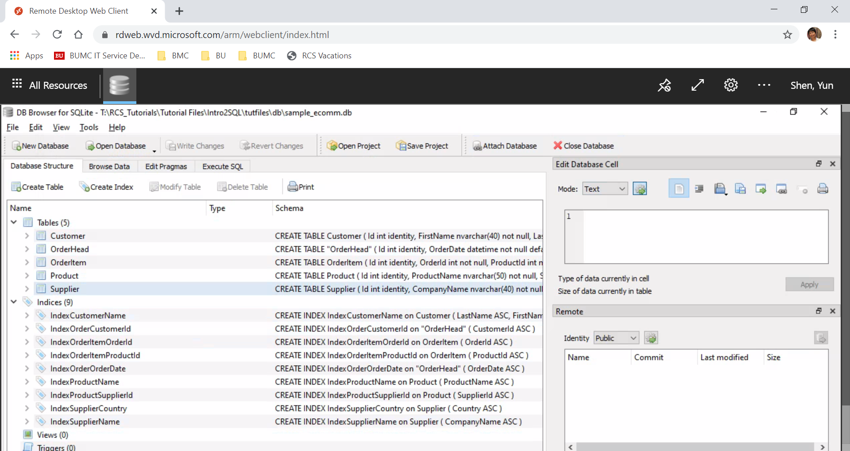

- Click on ‘>’ on the left of the table name, to expand the table and view the columns:
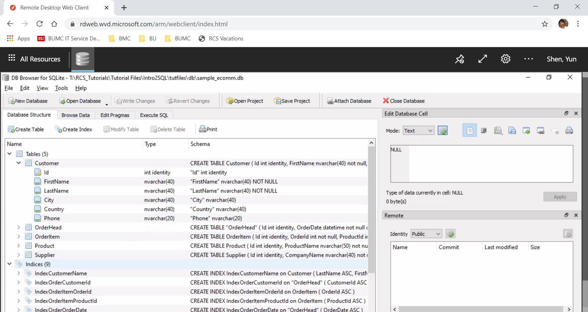

- Open ‘Execute SQL’ tab and click on ‘open SQL file(s)’ button:

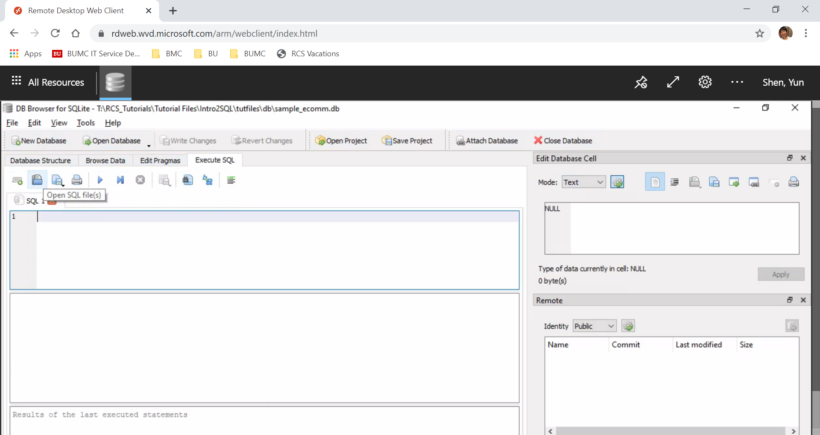

- Again ‘This PC -> Training Share Drive (T:) -> RCS_Tutorials -> Tutorial Files -> Intro2SQL->tutfiles->sql->sample_ecomm.db
- ’ to open the prepared sql script for the tutorial:

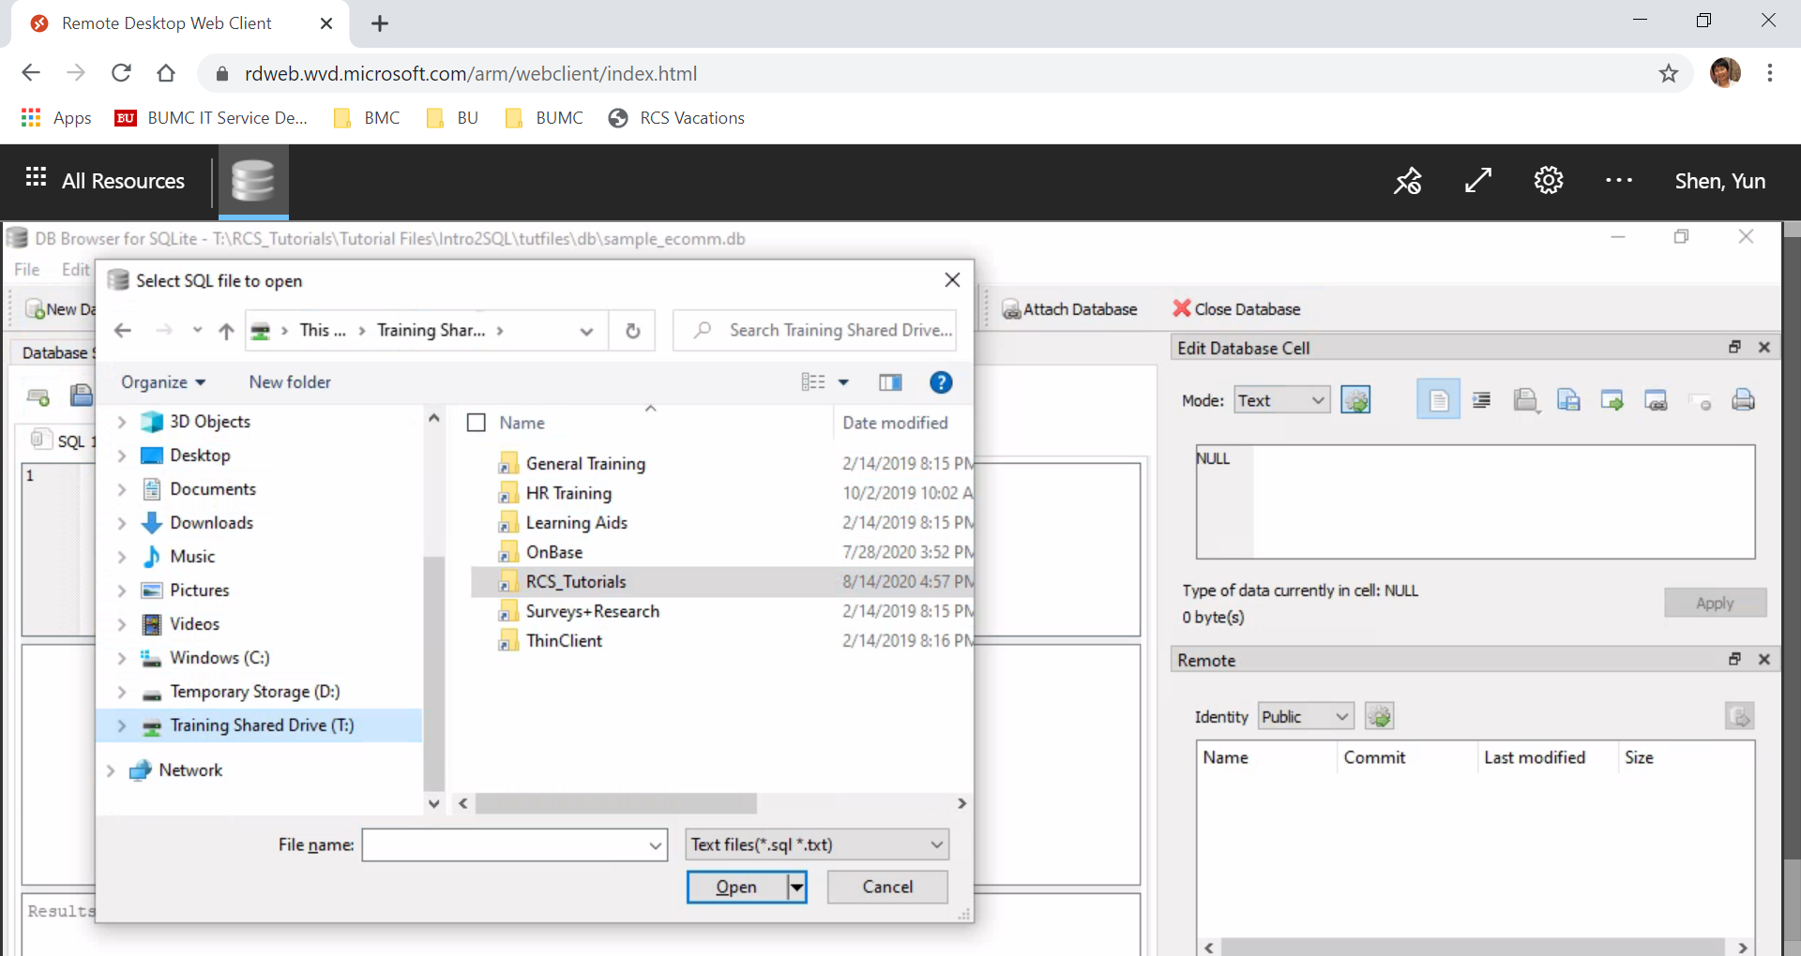

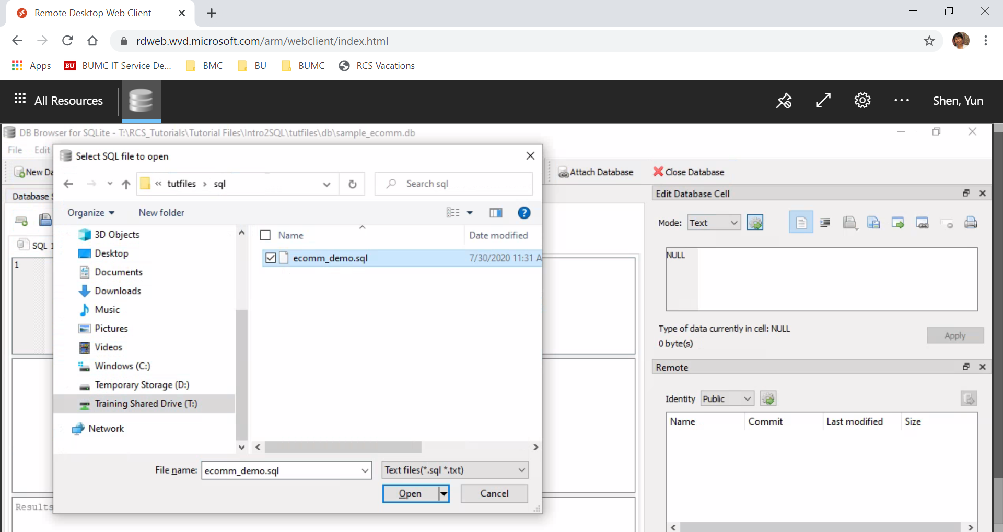

- This will open the SQL script loaded, and at this point, if there is(are) any extra window(s) open on the right, please close it:

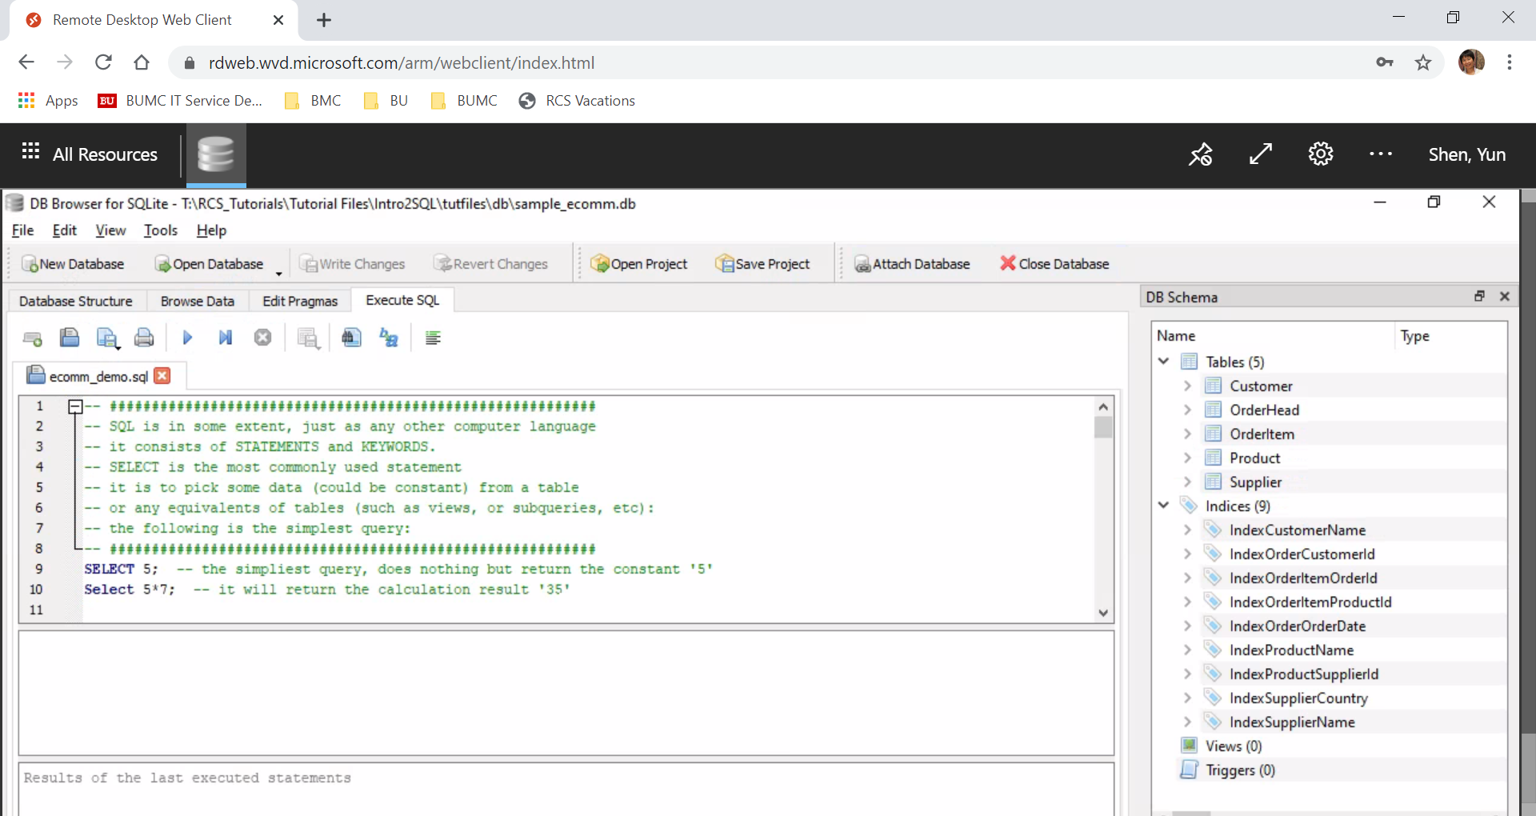
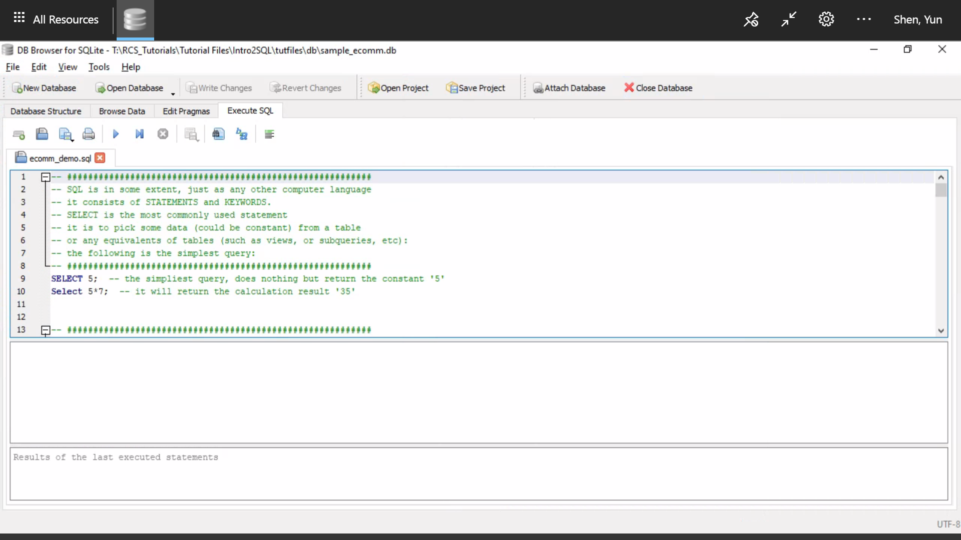

This ends this document for setting up the tutorial.

