This document is for the steps to follow to install DB Browser on your local machine

1. Windows (64bit)

Download the software at

<http://rcs.bu.edu/examples/db/tutorials/intro2SQL/tutfiles/software/win64/DB.Browser.for.SQLite-3.12.0-win64.zip>

and save it to some place on your local disk.

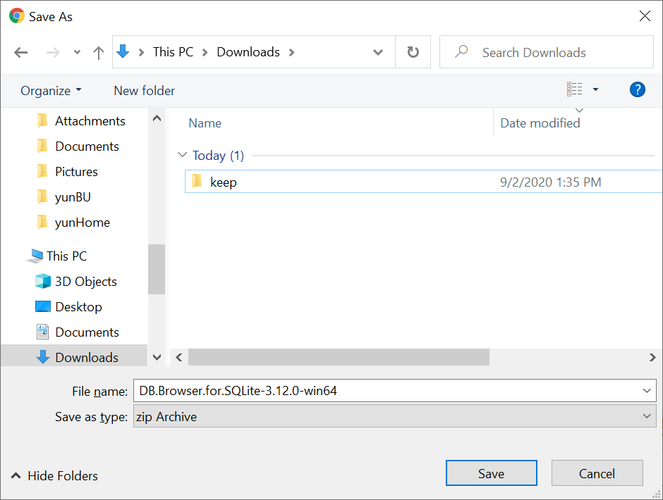



1. Extract the zip file you just downloaded:

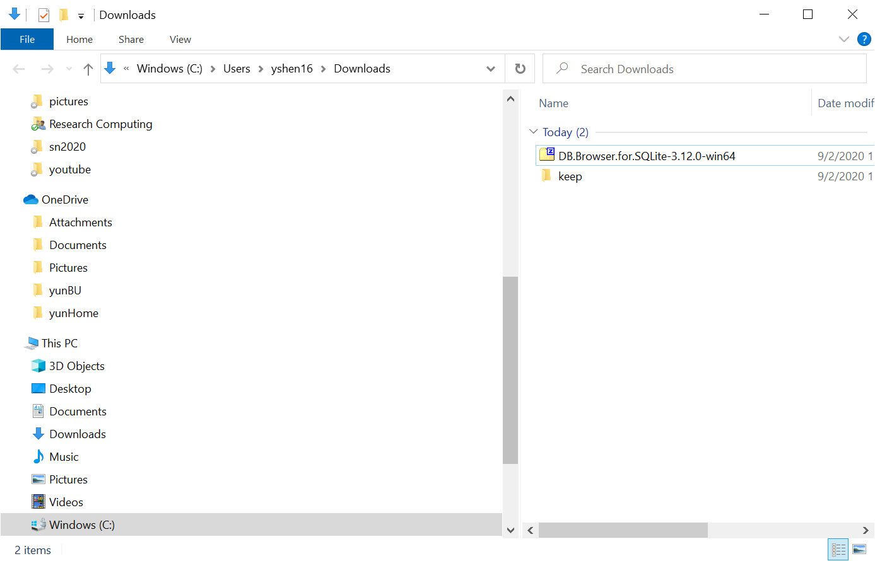



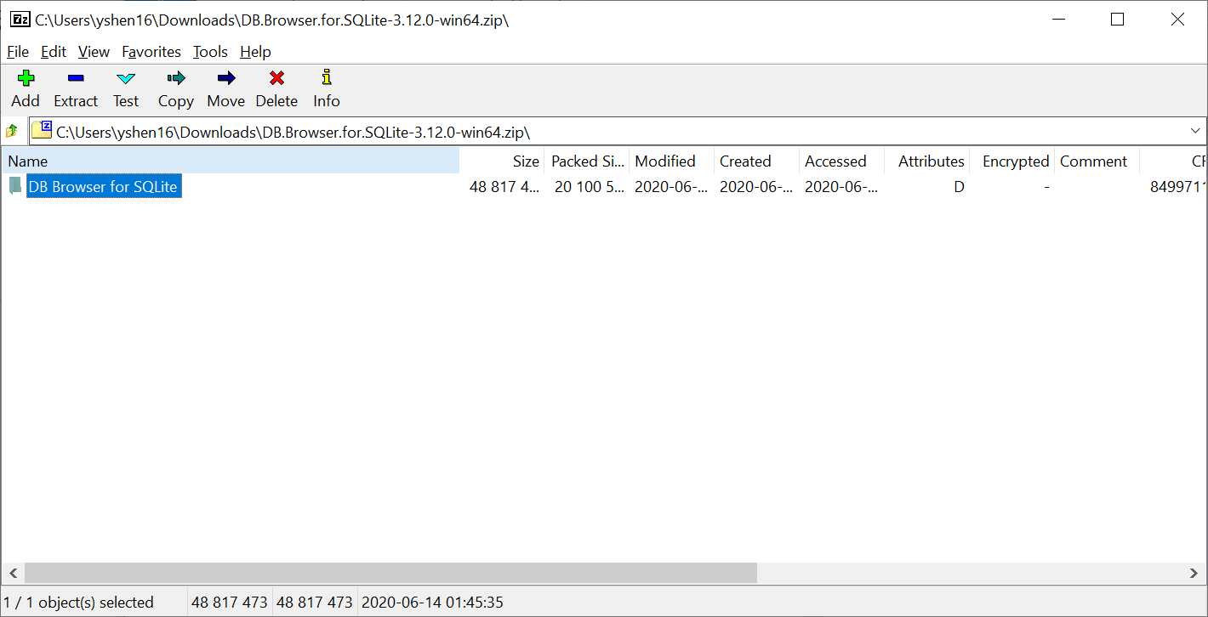



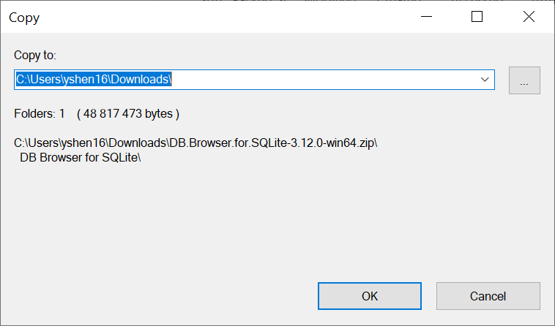



1. Open the extracted file folder ‘DB Browser for SQLite’:



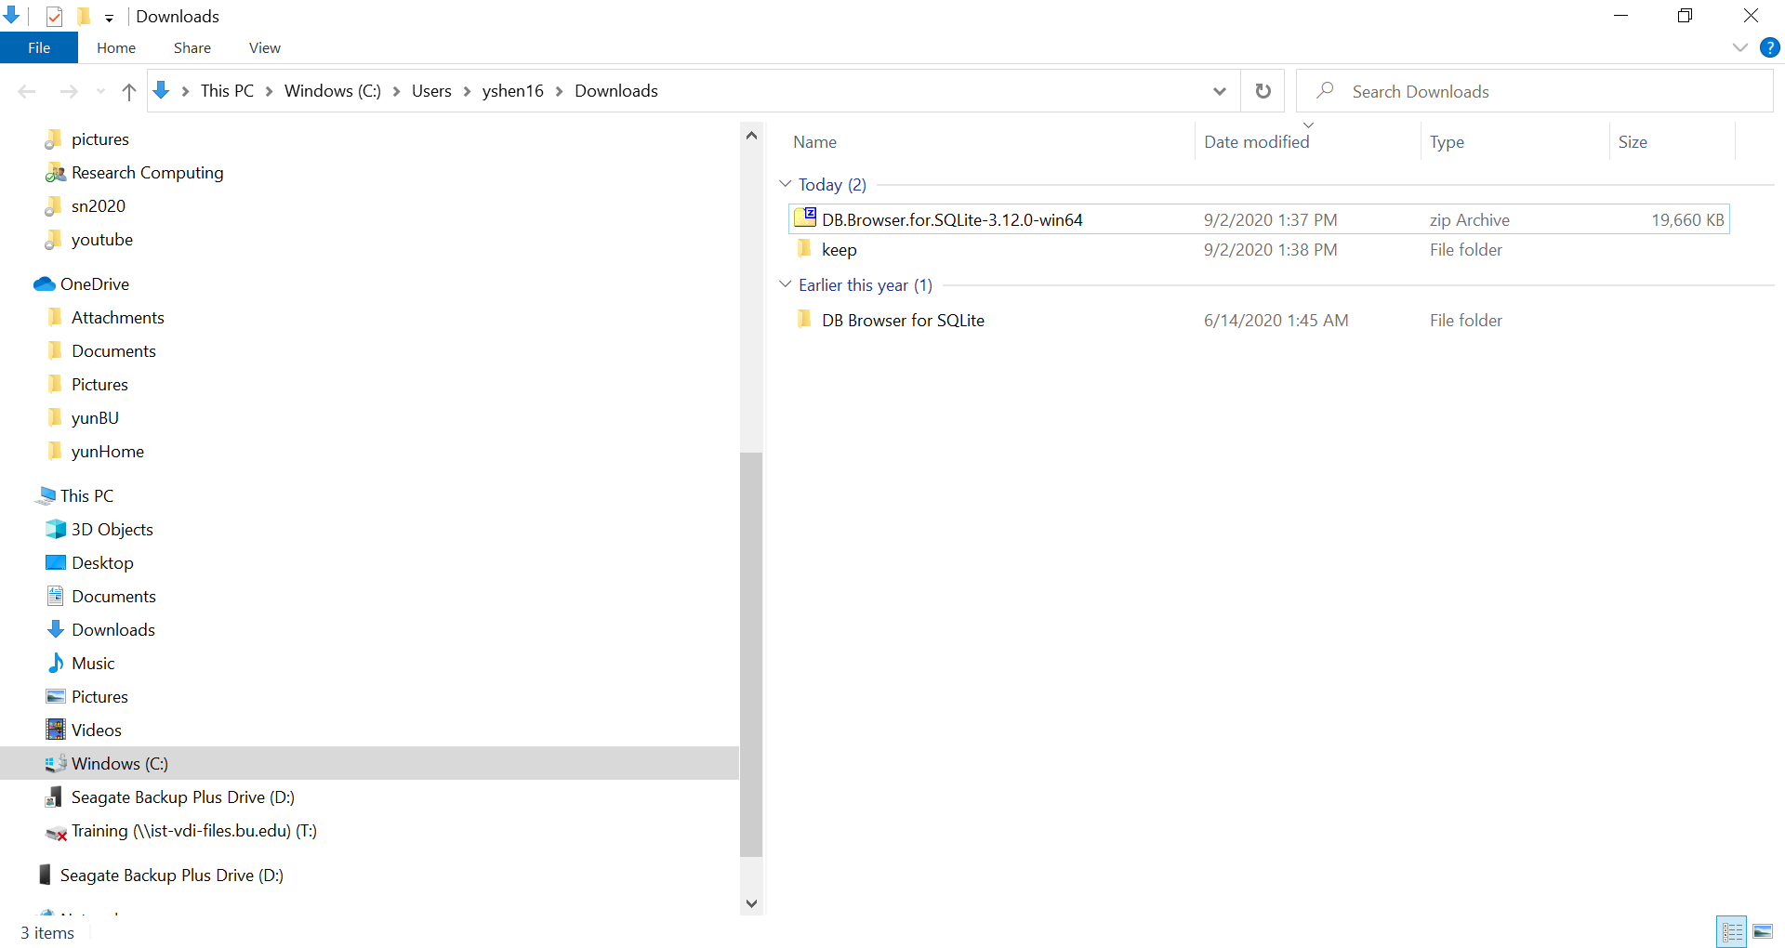



1. Browse through the file list and find the file named ‘DB Browser for SQLite.exe’ (the ‘.exe’ postfix may not appear in the file name)

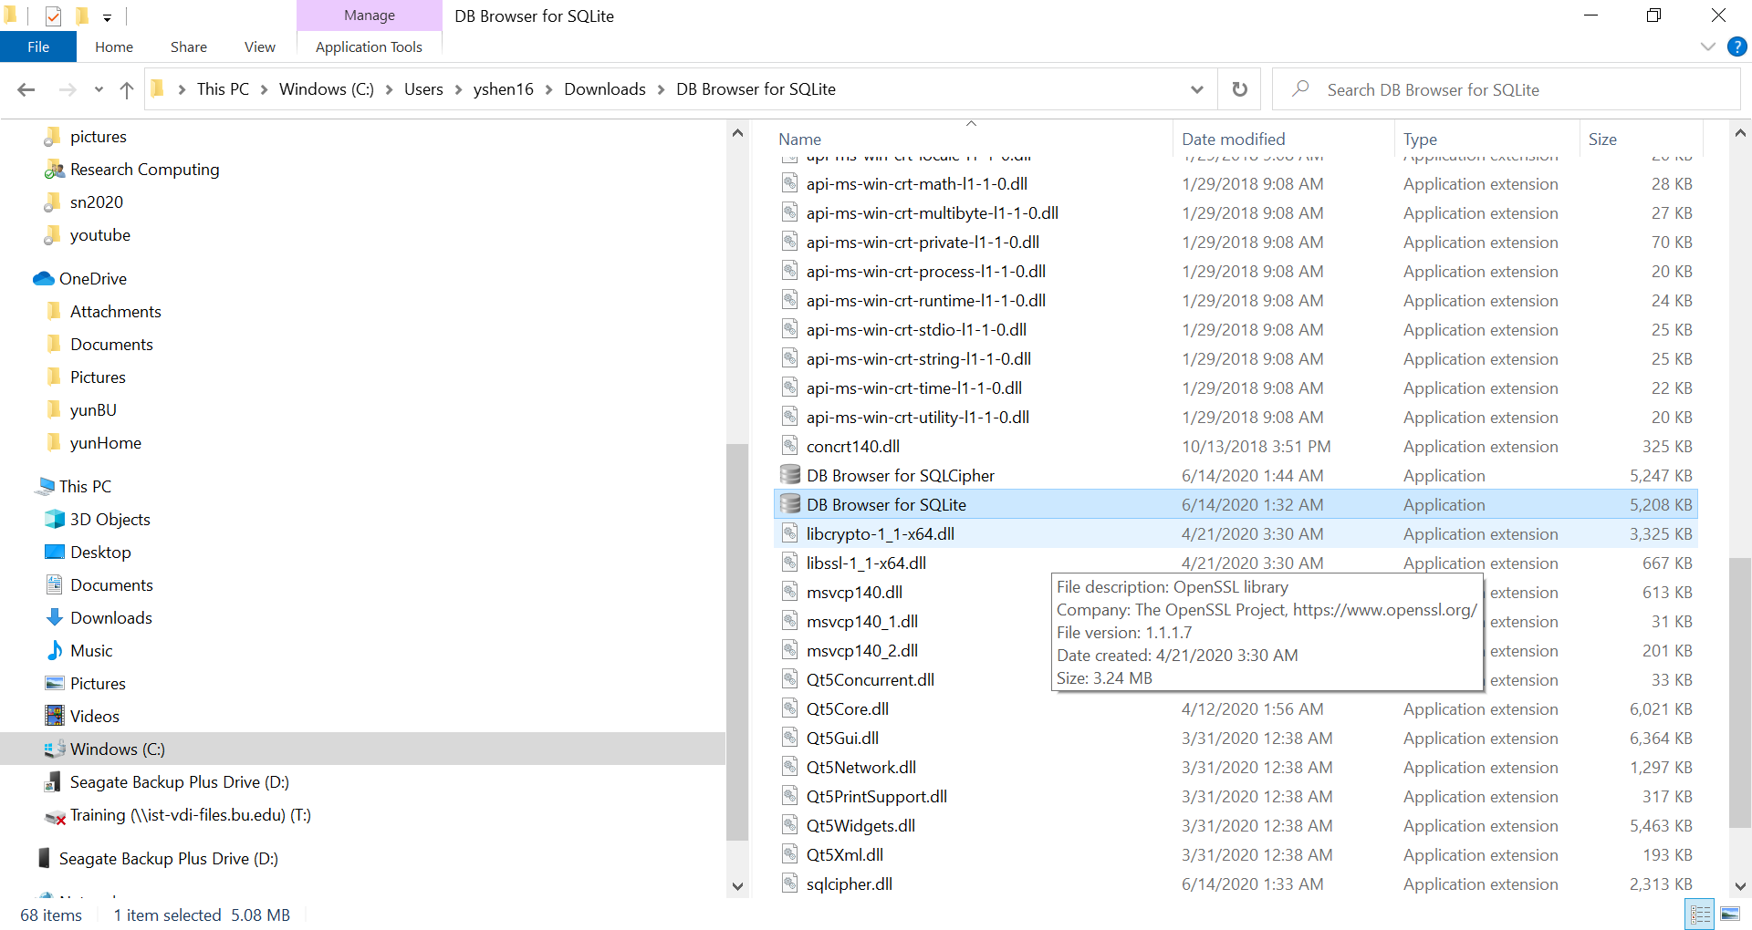



1. Put this exe file to desktop or the task bar for easy access:

