This document is for the steps to follow to install DB Browser on your Apple Mac machine

1. Mac OS 10.12 and above

Download the software at

<http://rcs.bu.edu/examples/db/tutorials/intro2SQL/tutfiles/software/mac/DB.Browser.for.SQLite-3.12.0.dmg>

and save it to some place on your local disk.

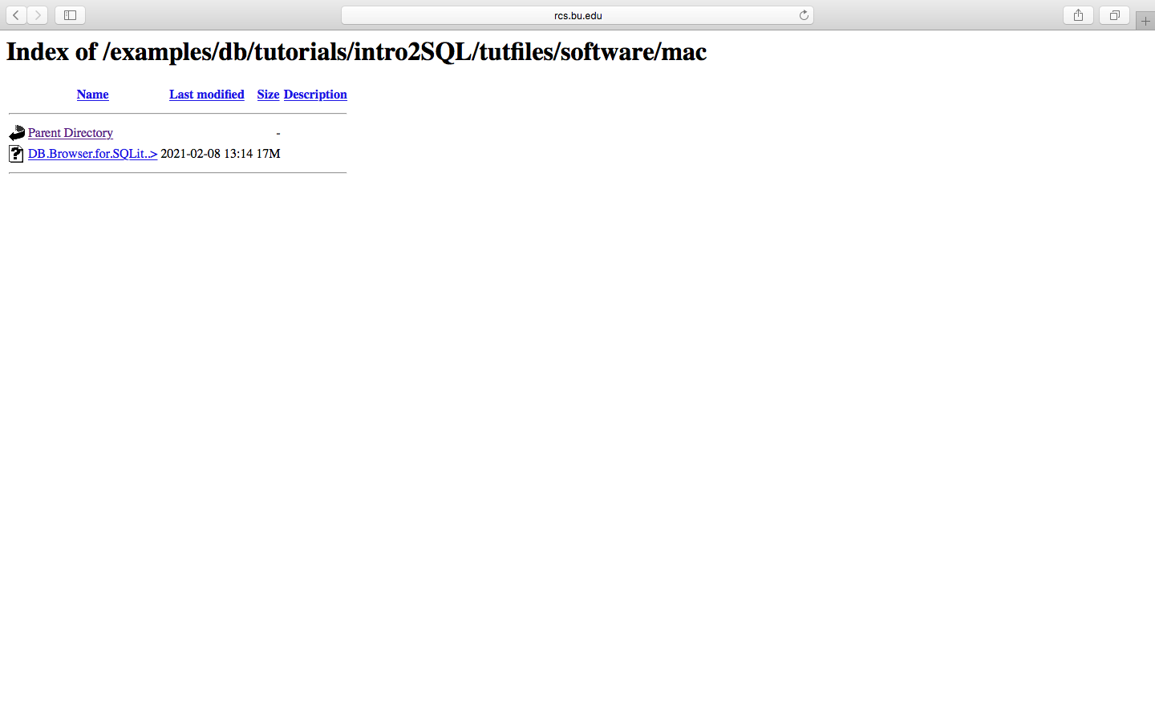



1. Double click the dmg file and open it:

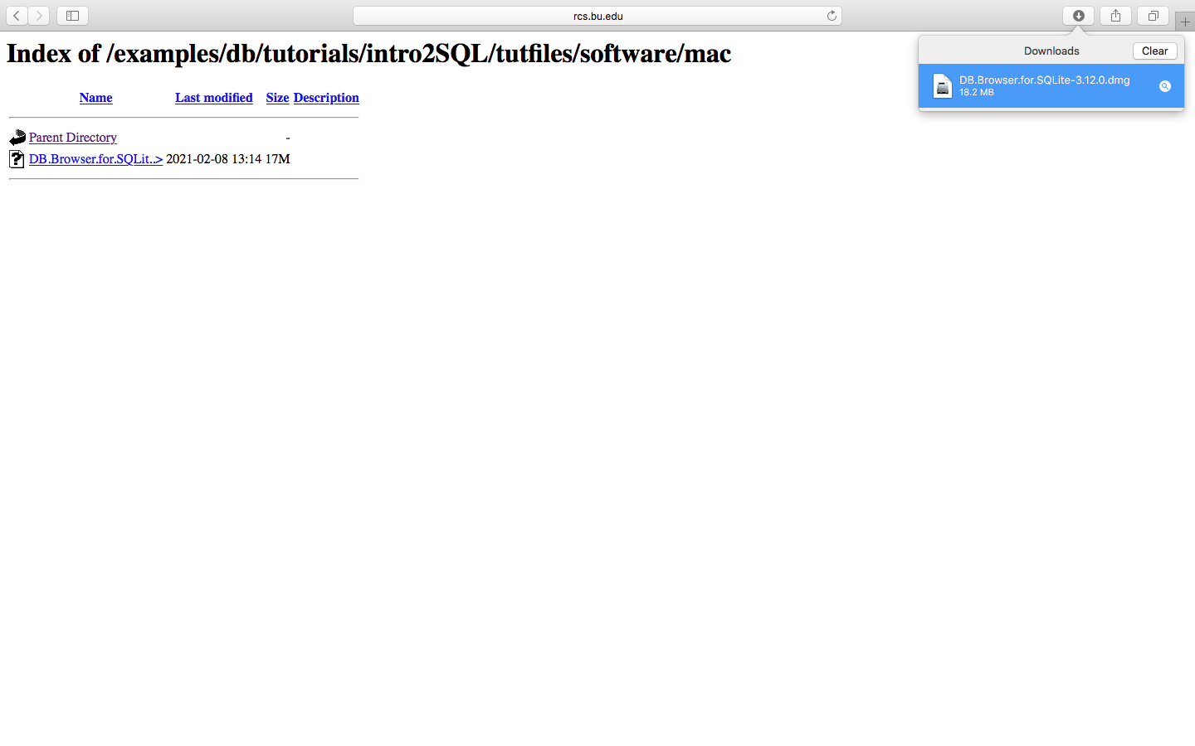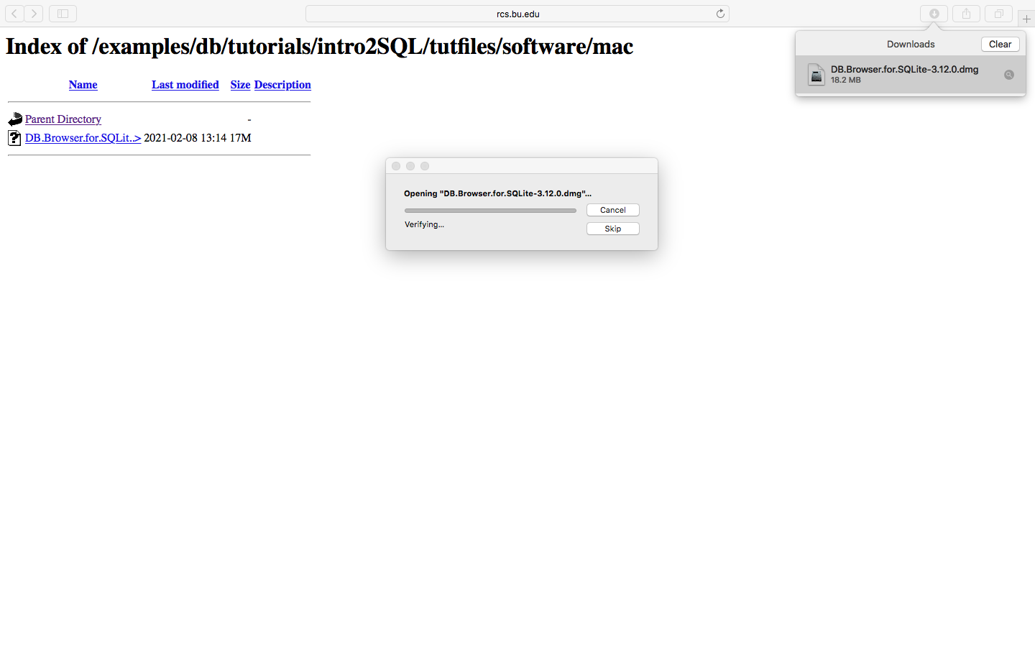



1. Move it to Applications folder:

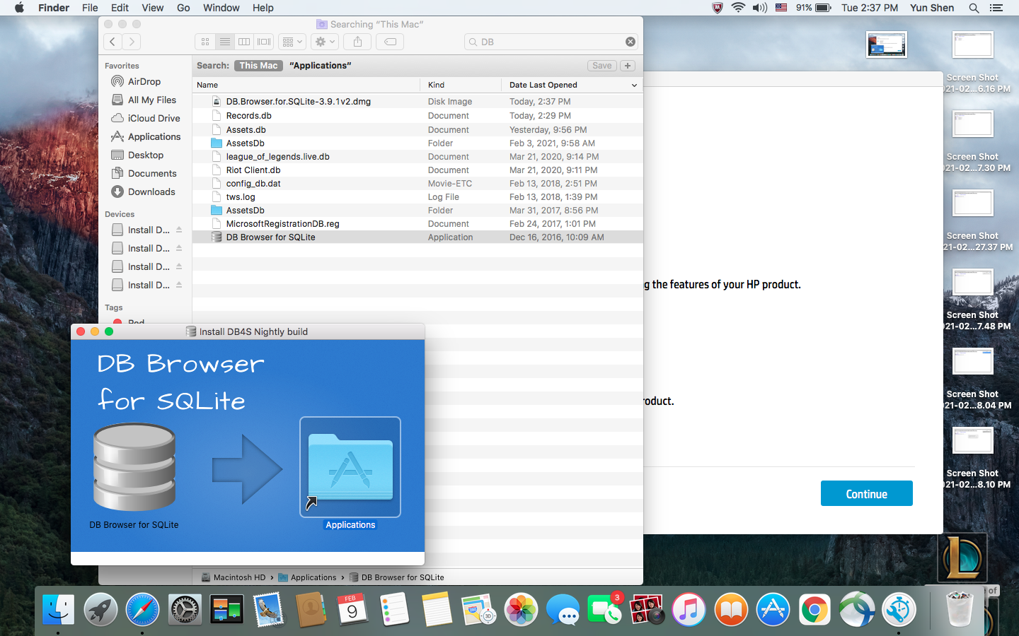



1. Double click the ‘DB Browser for SQLite’ application and open it (ignore the warning and click ‘OK’):

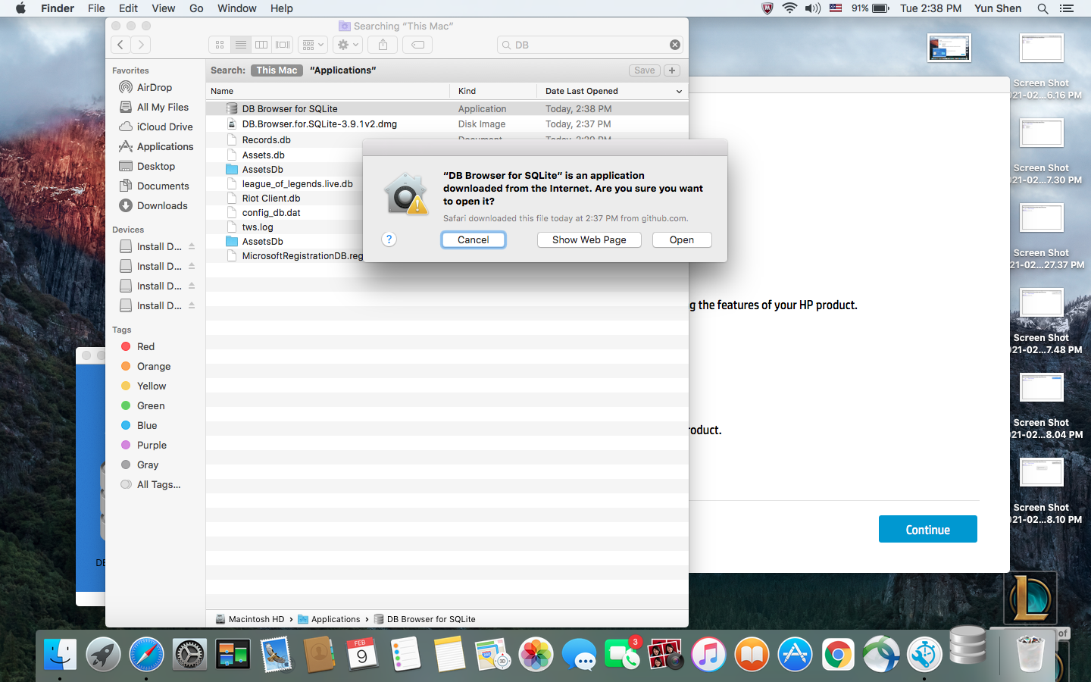



1. The follow is what it shall look like when DB Browser is opened and we can start from here to load the database and the sql script for this tutorial.

